**ST.XAVIER’S COLLEGE**

MAITIGHAR, KATHMANDU



**Computer Graphics**

Assignment #7

Submitted By:

Aashish Raj Shrestha

013BSCCSIT002

2nd year/ 4th semester

Submitted to:

|  |  |
| --- | --- |
| Er. Anil Shah  Lecturer  Department of Computer Science |  |

**Statement:**

Perform transformation in the image translation, scaling, and rotation.

1. **TRANSLATE:**

**Source Code:**

//---------------------------------------------------------------------------

#include <vcl\vcl.h>

#pragma hdrstop

#include "Translation.h"

//---------------------------------------------------------------------------

#pragma resource "*.dfm"

TForm1 *Form1;

//---------------------------------------------------------------------------

__fastcall TForm1::TForm1(TComponent* Owner)

: TForm(Owner)

{

}

//---------------------------------------------------------------------------

void __fastcall TForm1::TranslateClick(TObject *Sender)

{

int x=Image1->Width;

int y=Image1->Height;

int Tx=StrToInt(Edit1->Text);

int Ty=StrToInt(Edit2->Text);

for(int i=0; i<=x; i++)

{

for(int j=0; j<=y; j++)

{

int a=i+Tx;

int b=j+Ty;

Image2->Canvas->Pixels[a][b]=Image1->Canvas->Pixels[i][j];

}

}

}

//---------------------------------------------------------------------------

**Output:**

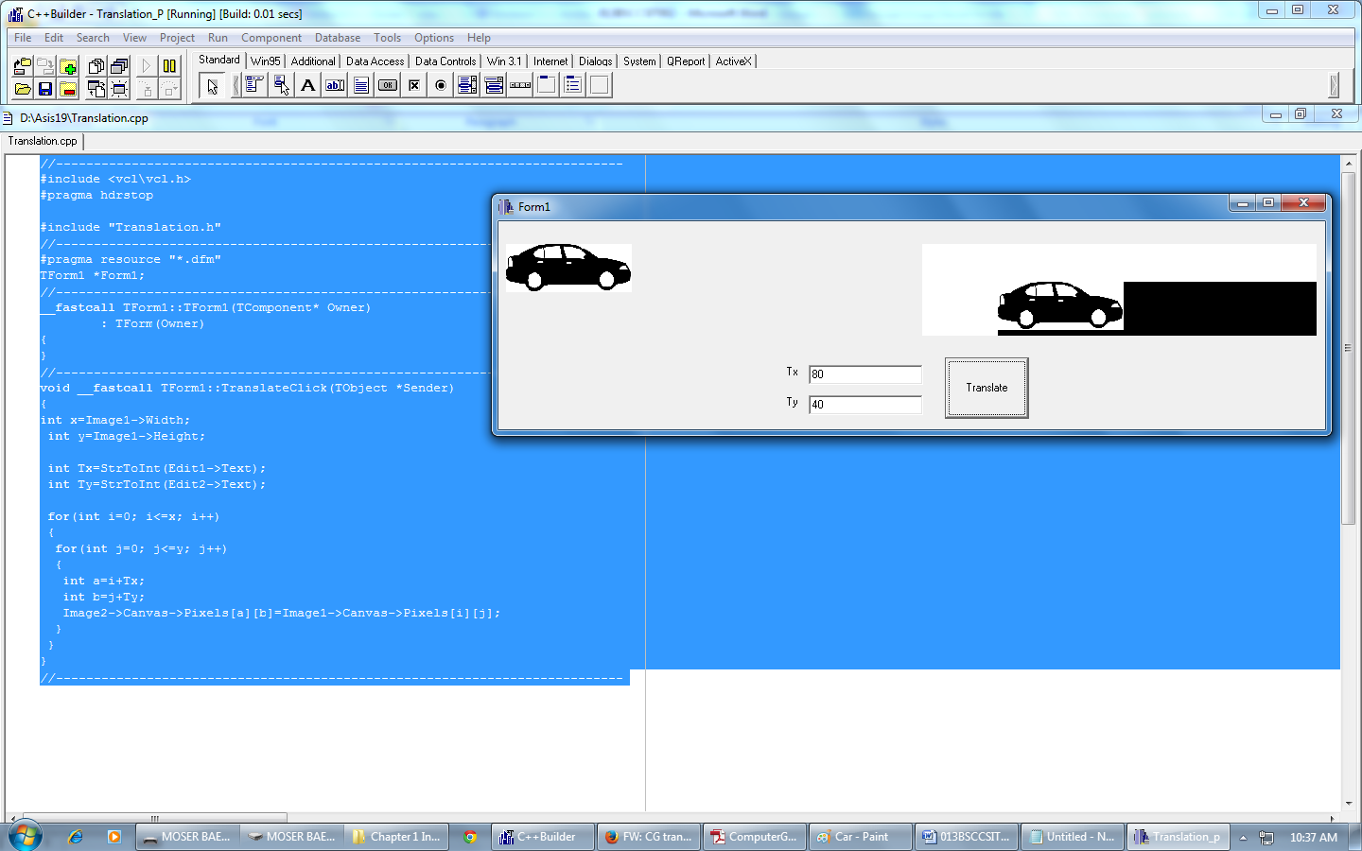

*Figure I: Translation of the Object*

**Conclusion:**

Hence, translation of object was performed using C++ Builder.

1. **SCALE:**

**Source Code:**

//---------------------------------------------------------------------------

#include <vcl\vcl.h>

#pragma hdrstop

#include "Translation.h"

//---------------------------------------------------------------------------

#pragma resource "*.dfm"

TForm1 *Form1;

//---------------------------------------------------------------------------

__fastcall TForm1::TForm1(TComponent* Owner)

: TForm(Owner)

{

}

//---------------------------------------------------------------------------

void __fastcall TForm1::TranslateClick(TObject *Sender)

{

int x=Image1->Width;

int y=Image1->Height;

int Tx=StrToInt(Edit1->Text);

int Ty=StrToInt(Edit2->Text);

for(int i=0; i<=x; i++)

{

for(int j=0; j<=y; j++)

{

int a=i*Tx;

int b=j*Ty;

Image2->Canvas->Pixels[a][b]=Image1->Canvas->Pixels[i][j];

}

}

}

//---------------------------------------------------------------------------

**Output:**

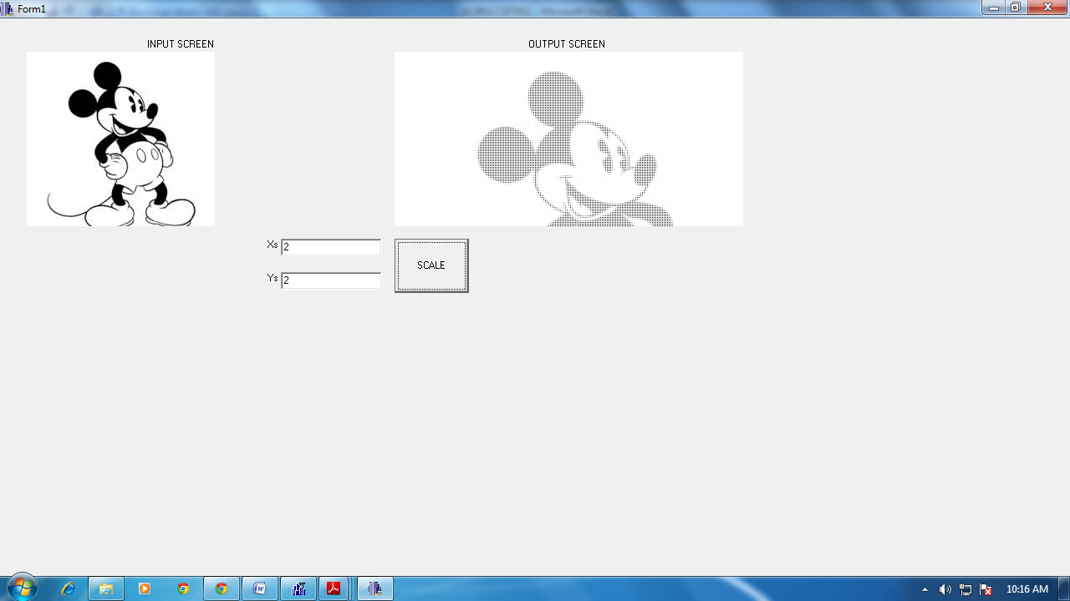

*Figure II: Scaling of the Object*

**Conclusion:**

Hence, scaling of object was performed using C++ Builder.

1. **ROTATE:**

**Source Code:**

//---------------------------------------------------------------------------

#include <vcl\vcl.h>

#pragma hdrstop

#include "SCALE.h"

#include "math.h"

//---------------------------------------------------------------------------

#pragma resource "*.dfm"

TForm1 *Form1;

//---------------------------------------------------------------------------

__fastcall TForm1::TForm1(TComponent* Owner)

: TForm(Owner)

{

}

//---------------------------------------------------------------------------

void __fastcall TForm1::SCALEClick(TObject *Sender)

{

int x=Image1->Width;

int y=Image1->Height;

int Tx=StrToInt(Edit1->Text);

for(int i=0; i<=x; i++)

{

for(int j=0; j<=y; j++)

{

int a=i*cos(Tx)-j*sin(Tx);

int b=j*cos(Tx)+i*sin(Tx);

Image2->Canvas->Pixels[a][b]=Image1->Canvas->Pixels[i][j];

}

}

}

//---------------------------------------------------------------------------

**Output:**

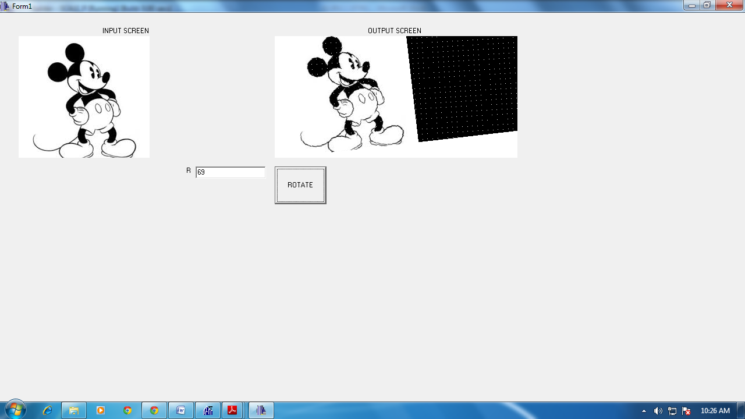

*Figure III: Rotation of the Object*

**Conclusion:**

Hence, rotation of object was performed using C++ Builder.